EXPERIMENT 4

Title: Normalization Techniques Using R Programming
Aim:
To demonstrate and compare Min-Max Normalization, Z-score Normalization, and Decimal Scaling Normalization techniques on the age data of 18 randomly selected adults in a hospital using R programming.
Algorithm:
1.Start the program.
2.Store the age data of 18 adults in a vector.
3.Apply Min-Max Normalization to scale values between 0 and 1.
4.Apply Z-score Normalization using the mean and standard deviation.
5.Apply Decimal Scaling Normalization by dividing the values by a power of 10.
6.Display the normalized values in a table.
7.Plot a graph to compare the three normalization techniques.
8.Stop the program.
Program:

# Experiment 4: Normalization Techniques

# Age data of 18 adults
age <- c(22, 25, 28, 30, 32, 35, 38, 40, 42,
45, 48, 50, 52, 55, 58, 60, 65, 70)

# Min-Max Normalization
min_max <- (age - min(age)) / (max(age) - min(age))

# Z-score Normalization
z_score <- (age - mean(age)) / sd(age)

# Decimal Scaling Normalization
j <- ceiling(log10(max(abs(age)) + 1))
decimal_scaling <- age / (10^j)

# Display the results
result <- data.frame(
Original_Age = age,
Min_Max = round(min_max, 3),
Z_Score = round(z_score, 3),
Decimal_Scaling = round(decimal_scaling, 3)
)

print(result)

# Comparison graph
matplot(age, cbind(min_max, z_score, decimal_scaling),
type = "b", pch = 1:3, lty = 1, col = 1:3,
xlab = "Original Age",
ylab = "Normalized Value",
main = "Comparison of Normalization Techniques")

legend("topleft",
legend = c("Min-Max", "Z-score", "Decimal Scaling"),
col = 1:3, pch = 1:3, lty = 1)
Output:
The program displays a table containing the original age, Min-Max normalized values, Z-score normalized values, and Decimal Scaling normalized values. A comparison graph is displayed in the Plots tab of RStudio.
Result:
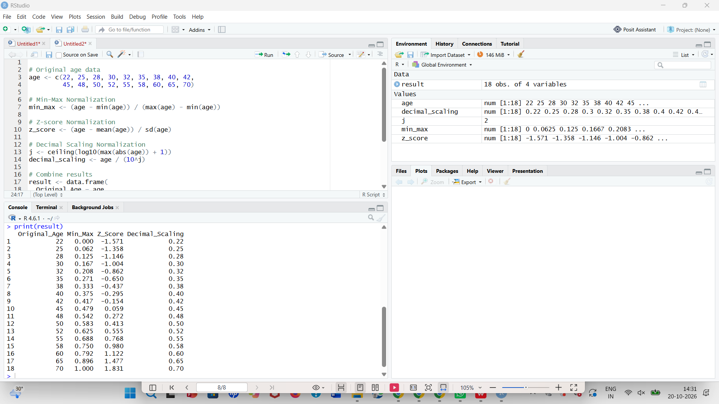
Thus, Min-Max Normalization, Z-score Normalization, and Decimal Scaling Normalization were implemented and compared successfully using R programming.

EXPERIMENT 5

Title: Min-Max, Z-score, and Decimal Scaling Normalization
Aim:
To demonstrate Min-Max Normalization, Z-score Normalization, and Decimal Scaling Normalization on the age data of 18 randomly selected adults using R programming.
Algorithm:
1.Start the program.
2.Enter the age data of 18 randomly selected adults.
3.Calculate Min-Max Normalization using the minimum and maximum age.
4.Calculate Z-score Normalization using the mean and standard deviation.
5.Calculate Decimal Scaling Normalization using a power of 10.
6.Display the normalized values.
7.Plot a graph to compare the techniques.
8.Stop the program.
Program:

# Experiment 5: Data Normalization

# Age data of 18 adults
age <- c(22, 25, 28, 30, 32, 35, 38, 40, 42,
45, 48, 50, 52, 55, 58, 60, 65, 70)

# Min-Max Normalization
min_max <- (age - min(age)) / (max(age) - min(age))

# Z-score Normalization
z_score <- (age - mean(age)) / sd(age)

# Decimal Scaling Normalization
j <- ceiling(log10(max(abs(age)) + 1))
decimal_scaling <- age / (10^j)

# Display results
result <- data.frame(
Original_Age = age,
Min_Max = round(min_max, 3),
Z_Score = round(z_score, 3),
Decimal_Scaling = round(decimal_scaling, 3)
)

print(result)

# Comparison graph
matplot(age, cbind(min_max, z_score, decimal_scaling),
type = "b", pch = 1:3, lty = 1, col = 1:3,
xlab = "Original Age",
ylab = "Normalized Value",
main = "Comparison of Normalization Techniques")

legend("topleft",
legend = c("Min-Max", "Z-score", "Decimal Scaling"),
col = 1:3, pch = 1:3, lty = 1)
Output:
The normalized values are displayed in a table with four columns: Original Age, Min-Max, Z-score, and Decimal Scaling. The comparison graph appears in the Plots tab.
Result:
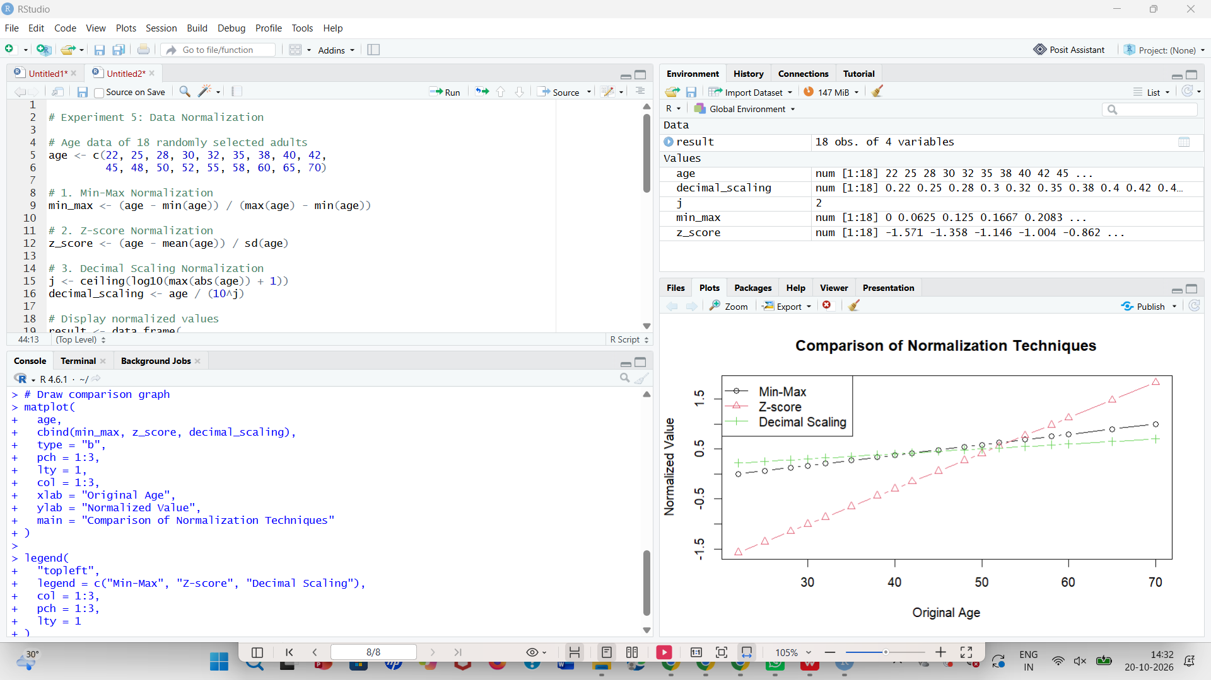
Thus, the three normalization techniques were demonstrated successfully on the age data of 18 randomly selected adults using R programming.

EXPERIMENT 6

Title: Calculation of Mean, Median, and Mode Using R Programming
Aim:
To calculate the mean, median, and mode of the number of pencils available in different boxes using R programming.
Algorithm:
1.Start the program.
2.Store the number of pencils in different boxes in a vector.
3.Calculate the mean using the mean() function.
4.Calculate the median using the median() function.
5.Calculate the mode by finding the value that occurs most frequently.
6.Display the mean, median, and mode.
7.Stop the program.
Program:

# Experiment 6: Mean, Median and Mode

# Number of pencils in different boxes
pencils <- c(10, 12, 15, 10, 18, 20, 15, 10, 25, 15)

# Calculate Mean
mean_value <- mean(pencils)

# Calculate Median
median_value <- median(pencils)

# Calculate Mode
mode_value <- as.numeric(
names(which.max(table(pencils)))
)

# Display results
cat("Number of pencils in each box:\n")
print(pencils)

cat("Mean =", mean_value, "\n")
cat("Median =", median_value, "\n")
cat("Mode =", mode_value, "\n")
Output:
Number of pencils in each box:
[1] 10 12 15 10 18 20 15 10 25 15

Mean = 14.5
Median = 15
Mode = 10
Result:
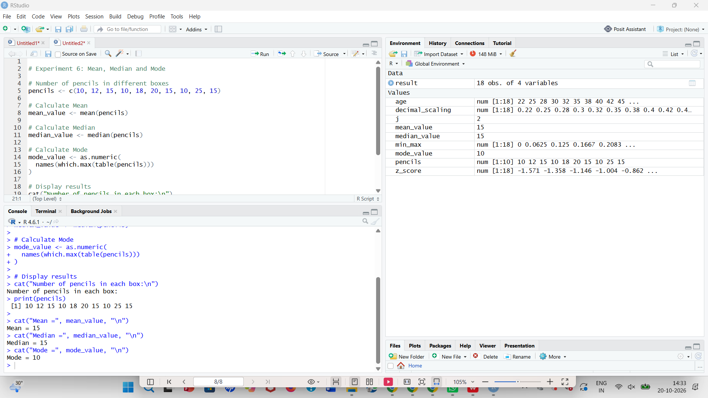
Thus, the mean, median, and mode of the number of pencils available in different boxes were calculated successfully using R programming.

